|  |  |
| --- | --- |
| Troop 94 Scout Guide  *What every scout needs to know about Troop 94* | http://www.clipartbest.com/cliparts/RTG/rqR/RTGrqRzTL.jpeg  *Your Scout uniform*  The scout uniform is a symbol of your membership in the Boy Scouts of America. The uniforms are designed to show we are united as one group. Uniforms are also a way to proudly display awards earned.  Class A uniforms are expected for meetings, outings and courts of honor. Your Class A uniform consists of a scout shirt, neckerchief, slide, scout pants, belt and scout socks. Class B uniforms are the casual uniform and are worn as decided by the Scoutmaster and Senior Patrol Leader. Your uniform should always be clean and neat. |
| https://d2ncbdssutn1hp.cloudfront.net/product-images/000/467/058/detail/boy-scout.jpg  Troop 94 meetings are held on ***Tuesday 7-8:30pm*** at the  Shiloh Fire Hall  Meetings include an opening ceremony, scout skills, advancement time, team building activities and a closing ceremony.  Several times throughout the year, meetings include special visitors, a field trip or an offsite activity.  Parents are always welcome to attend meetings and trips.  *Welcome to Boy Scout Troop 94!*  Our troop has been an active part of the Shiloh community since 1944. You have joined hundreds of other young men who chose to venture on the scouting journey. All scouts have their own goals. You decide what achievements you earn and when you earn them. Your leaders are here to guide and support you. Every Scout has the opportunity to be an *Eagle Scout*. With dedication, hard work and perseverance you too can earn this award. | *Your Scout HandBook*  As a prepared scout, you must have and use your official BSA Scout Handbook. This is a guide to skills and facts that are part of the scouting experience. The Handbook also serves as your record of complete skills, advancements, service hours, hiking and camping. It is important to keep an accurate up to date record of these important requirements of scouting. You will be expected to have your Handbook at each meeting.  *YOUR TROOP LEADERS*  The older boys in the troop have more experience in scouting than the new/younger scouts. These older scouts look forward to sharing their knowledge, skills and friendship with all new scouts.  The older scouts will serve as leaders in the troop to help the adult leaders. Boys may hold positions such as patrol leader, quartermaster, scribe, librarian, and historian to name a few. The troop is led by the Senior Patrol Leader (SPL) and the Assistant Senior Patrol Leader (ASPL). These scouts have been elected by their peers to direct and guide all troop activities.  As you advance in rank, you will have the opportunity to serve the troop in leadership roles. |

*TROOP COMMUNICATION*

There are several ways that you and your family will receive information about the troop:

1. The Announcement Board. This is updated, posted and reviewed at every meeting
2. Email. The scoutmaster may send information via email. Be sure that we have up to date contact information
3. REMIND app. This is a free app for smart phones through which the troop can send up to date messages. Sign up by sending a Text message to: 81010

Troop 94 access code: @9fadfc

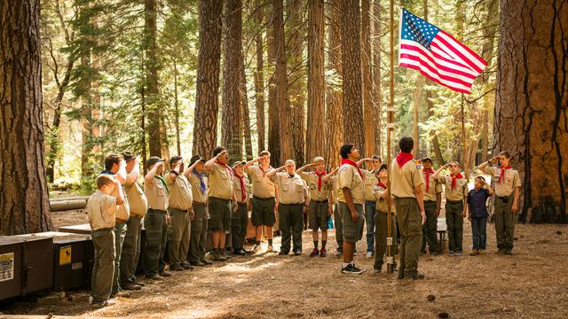

*WHO’s WHO?*

*Scoutmaster:*  Mr. Reiber

Assistant Scoutmasters: Mr. Bruder Mr. Stump

Mr. Harvey

Advancement Chairperson: Mrs. Stratford

Senior Patrol Leader: Jack Stump

Assistant Senior Patrol Leader: Jathan Tomes

Scribe: Kaegen McKee

Troop Guide for your Patrol: Jacob Stratford

Patrol Name: _______________________________

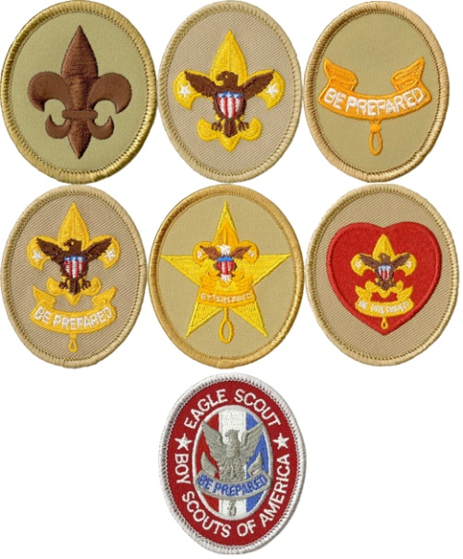

|  |  |
| --- | --- |
| *MERIT BADGES*  Merit badges are an important part of learning about new subjects or learning more about something that you have a basic knowledge of. You will work with a merit badge counselor to complete tasks required for the badge. There are 135 different badges to choose from, 12 are designated as “Eagle required”. In addition to those 12, an Eagle candidate must earn 9 additional badges of his choice. Your leaders can help you select Merit Badges of interest to you as well as determining the Eagle require badges.  *Advancement*  Advancement in rank comes with learning new skills and setting new goals. Scouts of Troop 94 are encouraged to be consistent with their scout journey by working on rank advancements and merit badges. Unlike Cub Scouts, Boy Scout advancement is determined by the scout himself.  There are seven (7) ranks in Boy Scouts: Scout, Tenderfoot, Second Class, First Class, Star, Life and Eagle. Our troop leaders help to guide scouts and provide opportunities for them to complete the requirements for each rank. Ultimately, the scout is responsible for setting his pace and meeting the requirements of each rank.  When you have completed the requirements for a rank, you will meet with a Scoutmaster for a Scoutmaster Conference. During that time, you and the Scoutmaster will discuss the requirements you completed, your activity/role in the troop, your understanding and practice of the Scouting ideals. Your Scoutmaster will also work with you on setting goals for yourself in scouts, at school and in the community.  The final step in a rank advancement is the Board of Review. After your Scoutmaster recommends you for a Board of Review, you will meet with a group of other adult leaders from the troop. The board may consist of other Scoutmasters or committee members. This group will review the completed requirements for the rank, discuss the skills you have learned, help you assess your Scouting experience and challenge you. With the approval of your Board, you will be awarded a rank advancement. One step closer to Eagle. | *DUES and other COSTS*  You will be asked to pay dues to be an member in good standing with our Troop. Dues are $1.25/week and are used to help with the cost of supplies, awards and outings. You may pay those dues weekly, monthly or for the entire year. Your troop scribe is responsible for maintaining the records for dues.  Camping trips will have a nominal fee associated with them to cover the cost of registration, the activity and food.  You will be asked to pay dues to be an member in good standing with our Troop. Dues are $1.25/week and are used to help with the cost of supplies, awards and outings. You may pay those dues weekly, monthly or for the entire year. Your troop scribe is responsible for maintaining the records for dues.  in good standing with our Troop. Dues are  in good standing with our Troop. Dues ar  *CAMPING*  Camping is the basis of many scout activities and skills. In order to advance in rank, you will to participate in camp outs. Troop 94 camps about nine (9) times a year, from weekend trips to week long summer camp. All camp outs incorporate scout skills, fun, and friendship.  You will be expected to be properly equipped for camp, having your 10 essentials as well as proper clothing, shoes, and gear. The experienced scouts and the adult leaders will work with you, so you learn what is needed (and what is not). |
| Be Prepared |  |